**Activity 1.3.8b**

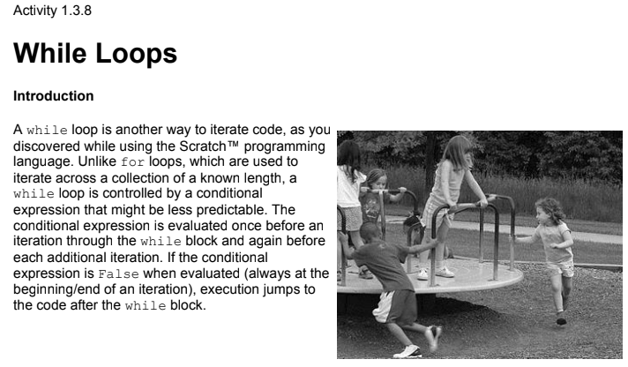

**Programming**

1. Define a function goguess() that implements a number guessing game as described below.

Strategize as pair programmers. Then iteratively code and test.

In []: goguess()

I have a number between 1 and 20 inclusive.

Guess: 6

# 6 is too low.

Guess: 10

# 10 is too high.

Guess: 9

# Right! My number is 9! You guessed in 3 guesses!

**Conclusion**

1. Describe the difference between a while loop and a for loop.
2. If you change between 1 and 20 from the previous program to between 1 and 6000, how many guesses will you need to guarantee that you have the right answer? Explain in comment code.
3. Reflect on how effectively you and your partner worked together. Individually, describe the strengths of your process and style, and describe what could be improved and how.